Prompt | Imagine that you are a supply chain analyst working at a grocery store distributor. You are tasked with developing forecasts, so that the company’s supply chain leaders have insight into future volumes of imported food to the US. You have been given a dataset, which contains the import values of edible products (food and beverages) entering U.S. ports and their origin of shipment from the U.S. Department of Commerce. Based on the dataset you have been given, complete the following tasks:

* Forecast FoodValues (in millions) for each of the Foods for 2023 (e.g., for Live meat animals, Meats... Beverages 3/ on the FoodValue tab).
  + Describe which forecast methodology you used and why you selected this method.
  + Which Food has the lowest forecasted value for 2023?
  + Which Food has the highest forecasted value for 2023?
  + How “trustworthy/believable” do you think your forecasting results are for the highest forecasted value for 2023?
* For the Food with the highest forecasted FoodValue for 2023, determine its FoodVolume for 2023 (using the FoodVolume tab).
  + Describe the direction and give the percent change of this Food’s FoodVolume between 2022 and 2023.
  + For the Food with the highest forecasted value for 2023, what country/geographic region will be the largest imported source (in millions)? (Hint: use the individual Food tab to locate country/geographic region information)
* If you did not have access to this time-series dataset, describe another forecasting method (e.g., qualitative) you could potentially use to determine what imported Food would have the highest FoodValues for 2023 (Hint: money is not an option/obstacle in this scenario)

Project Report

FORECASTING IMPORT VALUES AND VOLUMES OF FOODS FOR 2023

SCH-MGMT 663

ANAND GUPTA

Introduction:

The global food supply chain is a complex ecosystem influenced by numerous factors such as production, distribution, and economic trends. As a supply chain analyst at a grocery store distributor, the objective is to forecast the import values of edible products entering U.S. ports for 2023. This analysis aims to provide actionable insights for supply chain leaders to optimize procurement, inventory management, and distribution strategies.

In the United States, a staggering 30% to 40% of the food supply is wasted annually, accounting for over 60 million tons of discarded food. The magnitude of this waste calls for a solution, and one of the most effective ways to address it is through the utilization of sales forecasts. Creating a foundational, data-driven sales forecast can significantly reduce surplus products and aid companies in curbing food waste.

In a world where the imperative to reduce waste and enhance efficiency has never been more critical, the power of strategic forecasting shines brightly. As we’ve explored, the food industry grapples with the unique challenge of perishable products and ever-shifting demands. However, armed with sales forecasting, the industry can pave the way forward in sustainability. Food Manufacturing, 2023. Genevieve Shattow. <https://www.foodmanufacturing.com/supply-chain/blog/22876950/how-sales-forecasts-combat-food-waste-drive-supply-chain-sustainability>

What Is Forecasting?

Forecasting is a technique that uses historical data as inputs to make informed estimates that are predictive in determining the direction of future trends.

Businesses utilize forecasting to determine how to allocate their budgets or plan for anticipated expenses for an upcoming period of time. This is typically based on the projected demand for the goods and services offered.

F[ALICISTING, 2024. A TUOVILA](https://www.investopedia.com/alicia-tuovila-4687215), <https://www.investopedia.com/terms/f/forecasting.asp>

Methods

There are several methods which can be used in forecasting, few of them are;

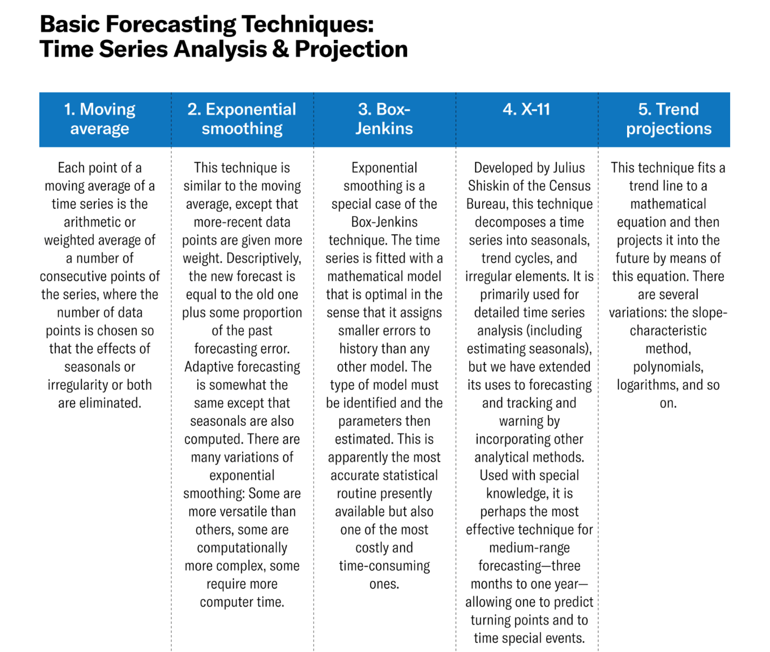Harvard Business Review, 2024. John C. Chambers, Satinder K. Mullick, and Donald D. Smith, <https://hbr.org/1971/07/how-to-choose-the-right-forecasting-technique>

To forecast import values and volumes for 2023 in this project, the Time Series Forecasting method, specifically the Exponential Smoothing model, was employed. Data provided by the U.S. Department of Commerce underwent cleaning and preprocessing to ensure accuracy. Assumptions were made regarding data stationarity and the absence of significant outliers. Exponential Smoothing was chosen because this method assigns more weight to recent observations and less to older observations, allowing the forecast to adapt to changing trends in the data.

Results:

The analysis generated forecasts for import values of various food categories for 2023. Visualizations such as line graphs depicted forecasted values over time, aiding in trend identification. The analysis also revealed insights into import dynamics, facilitating strategic decision-making. Results were presented with clarity, enabling stakeholders to interpret and utilize the information effectively.

Conclusion:

In conclusion, the analysis provides valuable insights into the anticipated import values of edible products for 2023. By leveraging the ARIMA model and analyzing historical trends, accurate forecasts were generated. This empowers supply chain leaders to make informed decisions, enhancing operational efficiency and ensuring the seamless flow of food products within the global marketplace.

In summary, the analysis offers a comprehensive understanding of import dynamics within the food supply chain, serving as a valuable resource for stakeholders in the industry.

References: